Fénix “Software de gestión empresarial”
Release 2.0

Basic setup instructions
Stand alone easy version

Welcome to Fénix “Software de gestión empresarial” Release 2.0. Before you install the software you must consider the requirements and kind of installation you need.
Requirements,
You will need a personal computer with one of the supported operating systems:
- Windows 2000 with Service Pack 3 or later installed
- Windows XP with Service Pack 1 or later installed
- Windows 2003 Server
Also you will need a SQL Server 2000 With Service Pack 3 installed in one computer accessible to all the client stations. The SQL Server 2000 need to be running in mixed security mode, use management console to turn security mode from integrated to mixed. If you hasn’t buy a valid license of SQL Server 2000, in the Fénix CD you will find a basic edition of SQL Server named Microsoft data engine, ready to install and use. It is yet upgraded with Service Pack 3 and is automatically installed in mixed security mode. Consider to upgrade to best editions if you experience low productivity, MSDE is intended for small amount of data and little number of users.
Fénix setup also installs if needed, a Run Time edition of Access 2003. This is needed for running the software.
Kind of installation,
If you are alone in your business, you will need to use a stand alone kind of setup. In the only computer you will install SQL Server and Fénix.
If you need to use more than one user at the same time, you will need to consider the client/server kind of installation. A LAN environment with a supported LAN protocol configured (As TCP/IP) is needed. One computer will run SQL Server 2000 and the others computers will run Fénix module. The data will be stored on the “server” machine and the other computers, the clients, will be used to work with the data stored on the server across the LAN. Installing Fénix also on the server is possible but may degrade the general efficiency and performance of the solution.
They are same modules but in different installation, depending if you need or not a multi-user environment to use the software.
The rest of this document is intended to help you on stand-alone environment. Consult the multi-user document if needed and it’s your situation.

Basic setup instructions for stand alone installation
This document is intended for helping in the single user installation mode of the software. Basically, it’s the same that a multi-user environment but if you only have 1 computer on your business, all the functions will run on this pc.
- Insert Fénix CD to begin web based installation
If you have not “auto run” enabled on you computer, please open index.html document on the CD.
- Clic on “COMENZAR” to begin the installation process.
- Check the minimum requirements screen
Carefully read the requirements about minimum hardware and software you need. Then click “SIGUIENTE” for to go to the next screen.
- Modules link screen.
First section is intended for install on “server” and “client” computers, second section is intended for install all the modules on the only computer of your business (Stand alone kind of installation)
- Begin Installation of SQL Server Deskop engine with Service Pack 3.
Click on step “1. SQL Server 2000 …” to begin installation of SQL Server 2000. If you already have installed your own licensed copy of SQL Server, you can proceed to step 7 and not to use the copy provided with Fénix.
- Complete Installation of SQL Server 2000 provided with Fénix CD..
When prompted, click on OPEN to start the setup process of SQL Server 2000 Desktop Engine. Click YES on security warning and wait to end the installation. Once Installed, click on “START” button and go to “PROGRAMS” and “START” group. There you will find “Administrador de servicios”. Run this program and using the green start button, put to work your SQL Server!
- Microsoft Jet 4.0 Service Pack 8
Due to new enhancements on security policies, Microsoft has released a new Service pack for Jet 4.0. It’s not required to install this upgrade but if you want avoid security warnings when launch Fénix, it’s recommended to download and apply this patch.

- Begin to install Fénix Release 2.0
Once you have a SQL Server installed on your LAN or computer and if desired a Patch applied for Jet 4.0, it’s time to complete the installation of Fénix. Click on the link “3. FENIX …” to launch the installer software and begin the installation of Fénix. Click on OPEN when prompted and Yes on the security warning. (Consider to check “Always trust on TecnoService”). Wait the installer decompress and launch the wizard.
- Complete the Fénix Installation
When the wizard begin the installation process, complete the steps:
- Click on “Siguiente” on the Welcome dialog to begin.
- Check “Acepto” to accept the terms and conditions of the end user license agreement and then click on “Siguiente”.
- Provide the user and company name and click “Siguiente”
- Click on “Típica” to install Fénix with all the modules needed. Use “Personalizada” indeed if you want to change the default installation folder.
- Click on the “Instalar” button to begin the setup process and let the wizard install all the software on your computer.
- Click on “Finalizar” when the wizard ends the installation process.

- Begin Fénix and setup your first company.
The software is yet installed on your computer. Your are ready to setup all the companies you need to manage with Fénix. Remember that our software is a multi-company, multi-year, multi-user software. You can setup how much companies as you need and activate every moment the company you want to work with. Every computer on the LAN must have activated any one of the companies at a moment. Review next the company creation summary.

Company setup when Fénix is installed on your system.
Repeat these steps for every company you want to setup and define on your system. Every company is independent and is allocated on their own database over the SQL Server. You must later to drop a database and then erase a company of your system.
The next steps review the basic configuration of your company. It will provide to Fénix the basic information to know how you want to manage every company, including legal requisites, name of the company and others.

- Begin Fénix Software
Use the Fénix Short-Cut to begin Fénix Software. Use the Start button, then Programs and Fénix. If you has not installed Jet Service Pack 8 you will be prompted about a security warning. Click on Yes to confirm to use the software. Click on “abrir” to open the software when you were informed about the digitall signed software. Consider to check “Always trust” on TecnoService.
- Use “Generar” button to begin the creation process
When you were on the Fénix Wellcome screen, use the “Generar” button to begin the creation process of your company. Next times, when you will have ready your own companies you will click on “Accept” but now we want to create a new company and then will need to click on “Generar”.
- Provide administrator user and password for SQL Server connection
Fénix needs to connect with special privileges to SQL Server, then you will need to provide a user name and password with administrator rights to create a new database on the server. If you used the SQL Server provided with the Fénix CD you can use “sa” as user name with blank password and then click on the arrow button.
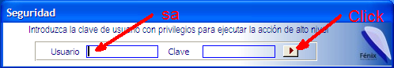
- Provide SQL Server to use and the name of the new database
When you provide security information, you must to provide the name of the instance of SQL Server you wants to use to store your new company. Remember that on your LAN you must have more than one SQL Server installed and every company must be allocated on a different SQL Server. If you use the SQL Server provided with Fénix CD the default name of your instance will be the name of your computer. You always must to click on “SQL Server services administrator” running near the Windows clock, to know the name of the instance you want to use.
Next you must to provide a name for the database that will store the information of your company, according to the rules that SQL Server meets for database names.
When you write this information, you will see a Green mark right the text boxes indicating all is OK. You must then press “Crear base de datos” to let Fénix begin to create tables, views and other components of your new database. When prompted click on Yes to confirm your decision, and wait the process to complete.
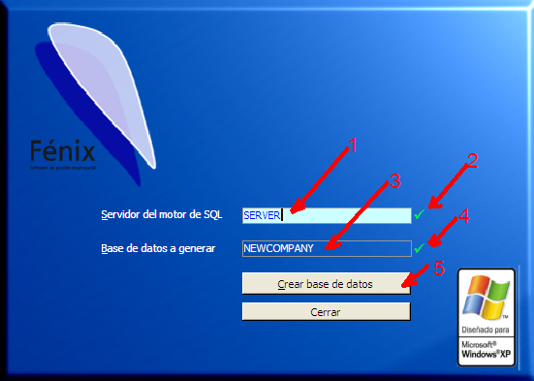

- Confirm to create basic data
After a minutes, the database and the tables to allocate the information of your company will be creates. Then Fénix will ask if you want to fill the tables with basic data. It’s highly recommended that you answer yes to this question. It will permits Fénix to insert basic information that all the companies need to run, for example the name of the world countries on the table “Countries” in order that when you create your own customers and need to specify the country of your customer it will be ready and you not need to change to the “Countries” form to add the country.
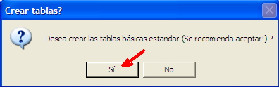
- Account codification style desired, legal level 4
If you answer yes on step 5 you will be asked how much digits you need for the level 4 of legal accounting of your company. Normally much companies uses 4 or 5 digits and is recommended you accept the proposed 4 digits and press “Aceptar” to continue, but you must use a different number of digits if your company need it.
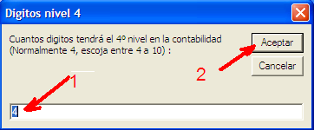
- Account codification style desired, legal level 5
As on step 6 you must provide the number of digits for the last legal accounting numbering system of your company. Typically you will be good with the value provided by the system, but you can change it if your company needs another value be legal considerations.
- Wait the process to complete
The system will need a minutes to insert basic data and adjust tables to the values provided. You must wait the process to complete. Click on “Aceptar” when you will get a “Process ended” dialog box”.
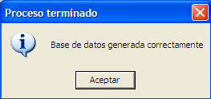
- Enter the Fénix software and connect to the new database
After close the “Process ended” dialog box, you will be returned to the Fénix Welcome dialog box. Then you must press “Aceptar” to enter the software. You will receive a Warning saying that there is no database connected on this moment. Accept the warning and continue entering.
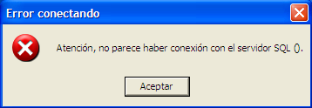
- Connect to the company you has created
As Fénix needs to be connected to a company to run it will conduct you to the “Connection” form for you to provide a company you want to use.
Press Accept and provide the SQL Server instance name and the database name you wrote on step 4 to connect to the database created.
Then press “Conectar” to let Fénix try to connect the company, if all runs ok you will see the name of the company on the title bar of Fénix. Initially as your company has no name, you must read “Pendiente de crear” as the name of your company”
Press “Cerrar” to close the connection form and be welcomed to Fénix!!
- Enter to provide information for your company
The first think you must do is to provide basic information about your company. This must be done by clicking on the company name on the central menu (First your company will be named “Pendiente de crear”.
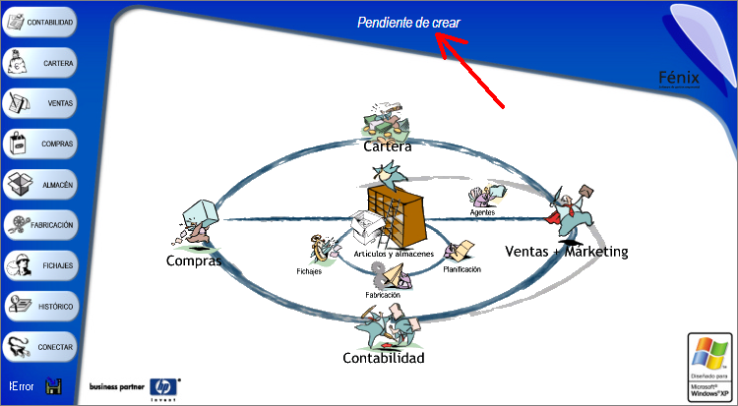

- Double click to access the configuration form for your company
Fénix provides a set of 5 related companies on the same database for use with special requirements companies with more than one legal accounting. You must activate one or all the sub companies if you need them. Fénix activates initially only one (the code number 100) and this will be good for the majority of companies. To configure the company number 100, you must double click on the first text box.
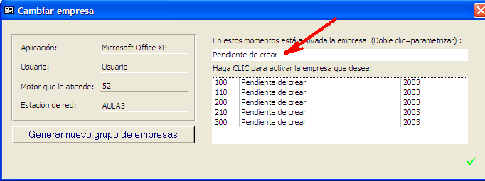

- Configure your company. Introduce name
On the configuration form, press on “Contabilidad” and provide the legal name of your company.
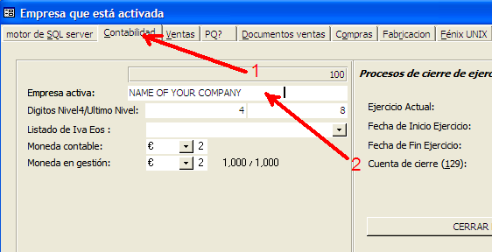
- Configure your company. Introduce street and contact information
On the configuration form, press on “Ventas” and provide the street and other legal and important information needed to be printed on invoices.
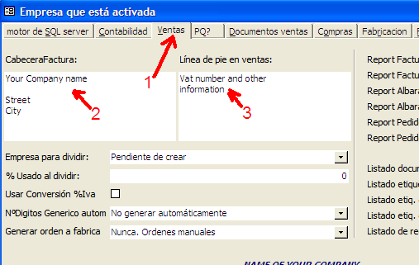
- Configure your company. How many invoices copies you need
You must finally introduce how many copies will you desire of your invoices and who is the destination of every copy. For example you will need first copy for legal requirements, second copy for mail to customer, etc. Repeat the process for every document you will need to use (Proposals, master document to let sign, invoices, etc…)
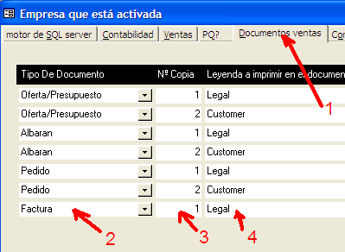
- End the configuration process
Close the configuration form using the green mark on the right bottom of the form. You will return to the select sub company form. Close also this form with the green mark and then you will be in the main menu.
You must begin to introduce data on you system. It’s ready for use. If you close now the Fénix software it will remember the company you was working on and next time you get in you will be working with the same company. If you need to change the company, use the “Conectar” button on left side bar of the main menu.

Thanks and enjoy,
We has been working very hard to offers you a strong product in witch you can confidence all the administrative process of you company. We hope you enjoy it and will be pleases to ear your comments. Remember you have a lot of supporting services with a cheaper costs.

